Tradesman killed, workmate injured in building collapse
Victoria
Date August 23, 2013

- Read later

Benjamin Millar Jessica Wright
- submit to reddit
- Email article
- Print
- Reprints & permissions

Tradesman loses life in building collapse
A 21-year-old man plunges 15 metres to his death, another man seriously injured in a dramatic collapse of a two-storey building in Melbourne’s south-east.
PT1M50S http://www.theage.com.au/action/externalEmbeddedPlayer?id=d-2se4u 620 349 August 22, 2013

- Video feedback
- Video settings
Authorities are investigating the cause of a building collapse that killed one man and left another seriously injured in Melbourne's south-east on Thursday.
WorkCover and Victorian Building Authority investigators will piece together events leading up to the collapse in South Caulfield that claimed the life of a 20-year-old carpenter.
Police say the two men fell about 10 metres when the top and mezzanine floors of the Hawthorn Road shopfront crashed without warning shortly after 10am, tapping them under the rubble.
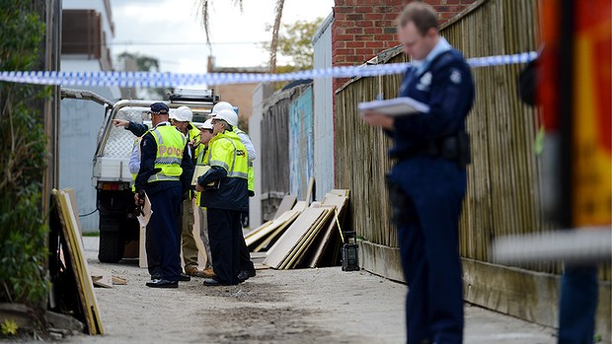
The scene of the Hawthorn Road building collapse in Caulfield. Photo: Pat Scala
Witnesses report hearing a loud crash as the floors gave way, narrowly missing two electricians working on the ground floor.

The pair tried desperately to free their workmates with the help of passers-by but were unable to save the 20-year-old.
A 48-year-old subcontractor pulled from the rubble was taken to The Alfred hospital in a serious but stable condition with fractured legs and a fractured arm as well as heavy cuts and bruising.
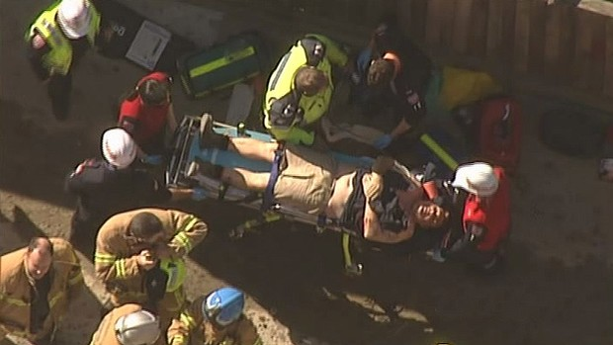
One man has died in the collapse which left another worker badly injured (pictured). Photo: Channel Nine
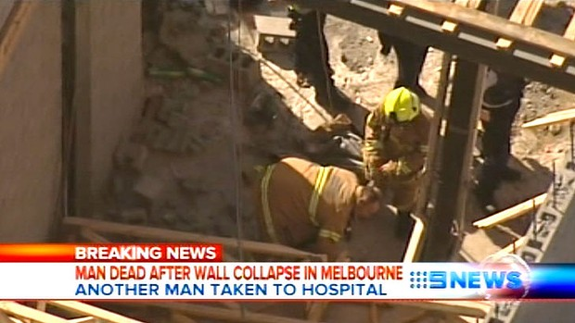

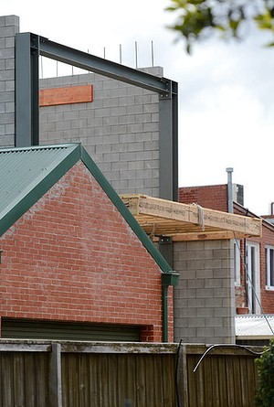

An Ambulance Victoria spokesman said paramedics were called to the site about 10am.
Emergency crews and Workcover investigators spent the day at the scene but will not speculate on the cause of the collapse until investigations are complete.
Renovation of the narrow shopfront between a pizzeria and a beauty salon began in late April.
Nick Love, 21, said he and emergency workers worked for about 10 minutes to pull wood off the men. ''Once we got to the [younger] guy, he was under a lot of stuff and I just stepped back and let the paramedics do their thing.''
Construction, Forestry, Mining and Energy Union spokesman Dan Murphy said the building site was not union affiliated, but CFMEU officials were attending the scene.
Victorian Building Authority chief executive Greg Hyams said as the state's new building industry regulatory body, the VBA was gathering information about the accident.
WorkSafe spokeswoman Rebecca Stoel said it had begun investigating.
Read more: http://www.theage.com.au/victoria/tradesman-killed-workmate-injured-in-building-collapse-20130822-2segh.html#ixzz34gDW8gqN
Read more: http://www.theage.com.au/victoria/tradesman-killed-workmate-injured-in-building-collapse-20130822-2segh.html#ixzz34gCxvZCN

